

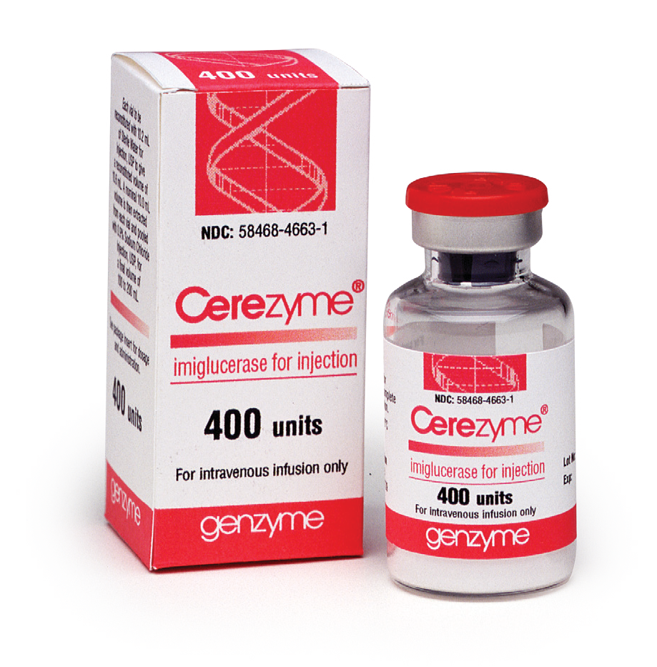 Dosage

Preparation & Administration
Cerezyme is administered by intravenous infusion over 1-2 hours. Dosage should be individualized to each patient.
- Initial dosages range from 2.5 U/kg 3 times a week to 60 U/kg q 2 weeks.
- 60 U/kg q 2 weeks is the dosage for which the most data are available.
- Disease severity may dictate that treatment be initiated at a relatively high dose or relatively frequent administration as per Physician.
- Dosage adjustments should be made on an individual basis and may increase or decrease based on achievement of therapeutic goals as assessed by routine comprehensive evaluations of patient’s clinical manifestations with guidance from the Physician.
Cerezyme is supplied as a sterile, non-pyrogenic, lyophilized product 400 Unit vials. Store at 2-8°C (36-46°F). Cerezyme does not contain any
preservatives; after reconstitution, vials should be promptly diluted and not stored for subsequent use.
- After reconstitution, Cerezyme has been shown to be stable for up to 12 hours when stored at room temperature (25°C) and at 2-8°C.
- When diluted, Cerezyme has been shown to be stable for up to 24 hours when stored at 2-8°C.

Recommended Ancillary Supplies

Preparation
- 1 mL, 10 mL, 20 mL, and 60 mL syringes
- 18 gauge – 20 gauge needles
- Supplies for proper aseptic preparation (e.g., Isopropyl Alcohol)
- Infusion bag (size dependent on product and dose)

Administration
- Programmable infusion pump is recommended if available
- Compatible intravenous infusion set
- In-line low protein-binding, 0.2 or 0.22 micron filter, optional

Notes on Particle Formation
- Translucent fibers (thin white strands of enzyme) may be visible in the reconstituted or diluted solution after preparation.
- Quantity of visible translucent fibers may increase over time. It is suggested to begin administration soon after preparation.
- Particles generate spontaneously but to a greater extent under stress
- To minimize this phenomenon, careful mixing and handling should be exercised (do not use pneumatic tube systems, exercise careful hand delivery, etc).
- Minimizing particle formation may also help avoid line occlusion at the filter.

General Practices

- Store vials in refrigerator and monitor refrigerator temperature at least once daily.
- Suggest not to reconstitute the product until patient is present and venous access is obtained.
- Use aseptic technique during preparation.
- Determine the number of vials based on weight/dose.
- Determine the total volume.
- Plan resources for preparation.

Preparation Technique

- Remove vials from the refrigerator and allow to reach room temperature (~ 30 minutes).
- Using strict aseptic technique, clean the vial stoppers and infusion bag with isopropyl alcohol per institution procedure.
- Add required volume of sterile water slowly, drop-wise, down inside wall of each vial. Do not use filter needles during preparation.
- Tilt and roll each vial. Do not invert, swirl, or shake.
- Visually inspect each vial for particulate matter and discoloration. Some translucent fibers may be present in the solution. Do not use if the solution is discolored or if there is particulate matter in the solution.
- Remove any air-space from the infusion bag. Remove the volume of sodium chloride solution equivalent to the dose of Cerezyme and then discard.
- Slowly withdraw the calculated volume of Cerezyme from the appropriate number of vials using caution to avoid excessive agitation. Do not use a filter needle, as this may cause agitation. Agitation may denature proteins, rendering them biologically inactive. Add this volume slowly and directly to the liquid in the infusion bag.
- Gently rotate, invert, or massage the infusion bag and visually inspect. Do not use if any opaque particles are present. Do not shake the solution.
Label the infusion bag with the patient name, “Cerezyme,” the dose, the total infusion volume, rates of infusion, preparation date/time, and expiration date/time, according to the facility’s policy.
The final infusion bag should be hand-delivered to the end user. Do not use a pneumatic tube or pharmacy cart as this motion can denature the protein.


Administration of Cerezyme

  - Prior to administration:
    - Obtain the patient’s baseline vital signs including blood pressure, temperature, pulse and respirations.
    - Obtain IV access; antecubital, wrist, hand veins may be used. If the patient has a port, access port as per protocol.
    - Draw the required blood work, if any ordered.
    - Connect the 0.2 micron in-line filter to the IV administration set (filter optional). Flush or prime IV Tubing and filter with 0.9% sodium chloride.
    - Connect IV administration set to the Cerezyme infusion bag.
    - Prime the IV administration set with Cerezyme being careful not to allow excess fluid to drip from the end of the set.
  - After the IV administration line has been primed, connect to the patient’s IV access or port.
  - Begin the infusion at a rate that will result in an administration length between 1-2 hours as instructed from the PI and the Physician’s orders.
  - Monitor the IV site for any infiltration.
  - Monitor vital signs at 15 minutes, 60 minutes and at the completion of the infusion or as directed by the Physician.
  - Do not infuse Cerezyme in the same intravenous line with other products.
  - Upon completion, discard infusion bag per institutional procedures.
  - Flush the infusion line with 0.9% sodium chloride to ensure the entire dose of Cerezyme has been administered. Use the last infusion rate tolerated by the patient.
  - Do not “IV push” the Normal Saline flush through.
  - After infusion, the line is flushed to deliver all of the medication that is in the infusion line; this can be done with control at the same rate as the drug.

If an allergic reaction to Cerezyme occurs, stop the infusion and manage accordingly. Contact the attending physician immediately.
Contact Sanofi Genzyme Medical Information at 1-800-745-4447


For more than 30 years, Genzyme has been committed to helping address the needs of people living with Gaucher disease and those who care for them.
The pioneer in Gaucher disease treatment, Sanofi Genzyme today brings unmatched years of research, development, and patient data to its Gaucher disease program. Sanofi Genzyme will continue to serve this community for years to come and remains committed to advancing Gaucher disease care through treatment options that address the range of patients’ disease status and lifestyle demands.
A Long-Standing Commitment to the Gaucher Community

www.cerezyme.com

50 Binney Street
Cambridge, MA 02142 U.S.A. 800-745-4447 or 617-768-9000
Fax 800-737-3642 or 617-591-7178
Monday - Friday 8:00 am-6:00 pm EST

Please see full Prescribing Information in back pocket.
Cerezyme is a registered trademark of Genzyme Corporation.
©2017 Genzyme Corporation. All rights reserved. GZUS.CERZ.15.03.0563(2)

